Juniata Flex - Summer 2026
Juniata College recognizes that workplace flexibility enhances an employee’s experience and overall well-being. To this end, we offer Juniata Flex, a program to recognize the different options for work that can help an employee balance professional and personal priorities while still maintaining the excellent service that all of you provide to our students, and to one another.

Program Requirements:
- For summer 2026 (beginning the first workday following Commencement and ending one week before the start of fall semester), core office hours for Juniata will be 9:00 am – 4:00 pm (M-F); all offices must be staffed, or coverage provided during these hours, as applicable. Generally, departmental response time to inquiries should be 24 business hours or less.
- Recognizing the importance of employee contributions to the student experience, a robust campus presence is desired for First Look Friday and Orientation events. Flex time off and remote work will begin May 18, 2026 and end August 14, 2025. Flex/Remote will not be available on the following dates: Friday, June 26; Monday, July 20; Friday, July 24. Previously scheduled vacation days will be honored.
- Individual job performance expectations should be met or exceeded before an employee is permitted to enter a Juniata Flex arrangement. This level of performance must continue throughout the arrangement.
- A supervisor’s ability to accommodate flexibility depends primarily upon the nature of the job.
- Prior approval is required through the employee's submission of an application to their supervisor; the supervisor and vice president must concur with the arrangement.
- Each division must maintain a comprehensive summer schedule (sample attached).
- Ongoing communication about the job and results is paramount.
- Flexibility may be adjusted or discontinued should job circumstances or departmental requirements change.
- The flexibility arrangement will be agreed upon, documented, and monitored for effectiveness.
- The standard work week is 37.5 hours during the academic year and 35 hours beginning the first workday following Commencement and ending one week before the start of fall semester.
- The Juniata pay week is Monday through Sunday. Support staff should not be scheduled to exceed 40 hours of work within the pay period.
- Any hours worked beyond 40 in a pay week must be paid as overtime for support staff.
- Employees must be on site as necessary to attend meetings, training sessions, or similar events or occurrences.
- Employees working remotely will provide telephone and internet service at their own expense. Long-distance charges will not be reimbursable.
  - Know your office line voicemail PIN and be prepared to change your greeting directing callers to an alternate way to reach you and regularly check your voicemail messages (either by dialing in or via voicemail-to-email in your Juniata Outlook Inbox).
  - Be prepared to forward calls to an external phone number or other line in your office for coverage. This must be done at your phone prior to leaving/working remotely.
- Generally, employees are not permitted to participate in Juniata Flex during periods of Family Medical Leave (FMLA), medical disability, or any other medical related leave. Employees must be healthy and available to work at the remote work location as if they were working at the on-site location.
- Employees who are unable to work due to illness must use sick, vacation, or personal time and must report their absence to their supervisor. Employees who wish to be relieved of responsibility for work on a particular day or days must use vacation or personal leave.

Implementation and Communication - The department head or designee will notify employees within the department and those whose areas are interdependent, how the arrangement will work.
Alternatives:
Human Resources is available to answer any questions on the alternatives and examples, in addition to the guidance provided below.
Departments and individuals should consider tasks and functions associated with a position before determining whether the position presents an opportunity for a Juniata Flex arrangement (see attached Feasibility Assessment.)
1. Flex Time: Variation in Hours and Days of Work
- Early start and end of day (e.g. 7am – 3pm)
- Late start and end of day (e.g. 10am – 6pm)
- Longer days; Flex time off (e.g. 4 longer days; 3 days off, or variations thereof, in accordance with the regularly scheduled hours)
- Variable days (when the schedule is other than M-F)
- Adaptable hours (working several hours, having a gap, and completing your workday)
- If 4 days flex, then no remote (may have option of either Flex Time or Flex Place)
2. Flex Place: Variation in Location of Work
- 1 Day remote (may vary by person in a department but during at least one day, all staff in office for meetings and collaboration)
- Remote when needed, as approved by the supervisor.
- Employees are responsible for the safety and security of all College property and proprietary information, if working offsite.
- Further tips about Telecommuting can be found in this link to the Article “Checklist for Working Remotely:” http://help.juniata.edu/view_article.php?article=138.
3. Reduced Schedules: Partial Year/Part Time/Job Sharing
- 9- or 10-month schedules for support staff (e.g. work academic year only)
- More use of part-time work (Up to 25 hours)
- Job sharing between individuals
- Compensation will be pro-rated accordingly.

Eligibility:
- The quality and timeliness of service within the department can be maintained for students, faculty, and other members of the Juniata community.
- The employee has been employed at Juniata College for at least 90 days.
- The employee has demonstrated sustained high performance and accountability, and the supervisor believes that the employee can maintain the expected quantity and quality of work while in a Juniata Flex arrangement.
- The employee has demonstrated time management, self-motivation, independence, and dependability in accomplishing work assignments.

Approval:
The employee and supervisor discuss and document a Juniata Flex proposed work arrangement by using the Juniata Flex feasibility assessment and proposed work agreement (see below.) The document is discussed and reviewed by the area vice president. Human Resources may consult on the Juniata Flex feasibility assessment and proposed work agreement for compliance with all applicable laws and regulations (FLSA, Tax, etc.) If approved, Human Resources should be sent a copy of the document and will maintain a copy of the signed Juniata Flex Agreement in the employee’s personnel file. Divisions should provide a copy of the master schedule to Human Resources.
Employee Characteristics for Success in a Juniata Flex Arrangement:

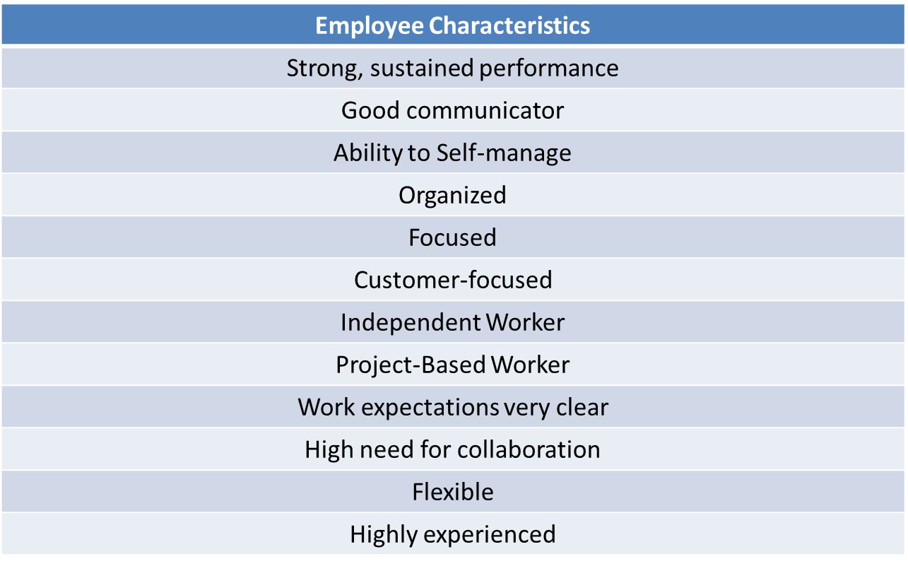

Revised 4/1/26


Divisional Master Schedule SAMPLE
2026 Summer Flex
NAME | FLEX/Remote | DAY | HOURS | VACATION DATES
Department
Department
Department
Department
Department

Juniata Flex Job Feasibility Assessment and Application
This document is used to help the supervisor and employee determine the feasibility of a particular position to be engaged in a Juniata Flex arrangement. The document will also assess the employee’s and supervisor's work styles and determine if the styles would support a Juniata Flex arrangement.
Staff Member Name: Position Title:
Name of Supervisor: Department/Unit:

Job Assignments and Duties:

List the key duties and percentage of time allocated to each duty.
1. | %
2. | %
3. | %
4. | %
5. | %

Can the time spent on the above type of tasks support a Juniata Flex arrangement? ☐Yes ☐No
If not, can you rearrange the position’s duties (performed on the same day) to support the arrangement?
☐ Yes ☐ No
Employee Assessment – Key Duties: This section will help you determine if the position’s key duties lend themselves to a Juniata Flex arrangement.

Do key duties require ongoing access to equipment, materials, and files that can only be accessed on Juniata property? ☐ Yes ☐ No
Do key duties require extensive face-to-face contact with supervisors, other employees, clients, or the public on Juniata’s property? ☐ Yes ☐ No
Do key duties require extensive time in meetings or performing work on Juniata’s property? ☐ Yes ☐ No
If you answered ‘Yes’ to any of the above questions, telecommuting might not be appropriate, however, other Juniata Flex arrangements might apply.
What percentage of time is required on Juniata’s property? _________ % time

Employee Assessment – Self-Directed Work: This section will help you determine if the employee can work in a self-directed manner in managing work and time.
General:
Does the employee have a complete understanding of job and performance expectations? ☐Yes ☐ No

Does the employee regularly demonstrate that their approach to work is organized and dependable?
☐ Yes ☐ No
Is the employee highly productive? ☐ Yes ☐ No
Does the employee regularly meet deadlines? ☐ Yes ☐ No
For Remote Work Consideration:
Can the employee work independently without constant supervision? ☐ Yes ☐No
Can direction be provided by the phone? ☐ Yes ☐No
Does the employee need/desire to be around coworkers? ☐ Yes ☐ No
Does the employee have a suitable workspace at home (if remote is considered?) ☐ Yes ☐ No
Are there known distractions at home (e.g., interruptions due to dependent care)? ☐ Yes ☐ N o
Can the employee work in an environment with little structure? ☐ Yes ☐ N o
Does the employee have the technology, including computer, appropriate software, and remote access capability, to work from home? ☐ Yes ☐No
Can the employee’s performance at home be measured? ☐ Yes ☐ No
Based on the above, does the collective weight of Yes answers support the employee being a remote worker? ☐ Yes ☐ No
Supervisory Assessment: This section will help you determine if your managerial/supervisory style supports a Juniata Flex arrangement and specifically, remote work.
Are you comfortable allowing this employee to work autonomously? ☐ Yes ☐No
Do you provide solutions when requested for assistance? ☐ Yes ☐ No
How frequently do you monitor employee work performance? ☐Daily ☐ Weekly ☐ Other Intervals
Are you comfortable communicating via email or telephone, vs. face-to-face? ☐Yes ☐No
Are you able to establish clear objectives for this role? ☐ Yes ☐ No
Can you accurately measure the employee’s performance and outcomes? ☐ Yes ☐ No
Can you accurately measure the employee’s time worked? ☐ Yes ☐No
Do you trust that the employee will be productive without direct supervision? ☐Yes ☐No
Based on the above, does the collective weight of ‘Yes’ answers support the employee being eligible for a Juniata Flex arrangement? ☐ Yes ☐No

General Agreements for the Juniata Flex arrangement:
Employees permitted to engage in a Juniata Flex arrangement remain subject to the terms and conditions of employment set forth in the College’s Policies and Handbook. This agreement does not constitute an employment contract.
This arrangement will be in effect for _______________________(Specify time period) and will be reviewed monthly for effectiveness of the arrangement and renewal. This arrangement may be revoked by the College to meet its educational and business purposes at any time.
In addition to my existing obligations and responsibilities, I agree to do the following:
- Maintain a regular, documented work schedule (core hours of work) and an accurate accounting of what they work on and when. During these hours, I will be available via email and telephone/voicemail.
Work days:

Scheduled “core” hours of work:

Contact email and phone (Note: employee’s office phone line is to be forwarded to this number):

I request Remote Work on the following basis:
The Remote Work would occur on (days):_______________________________________________
The Remote Work hours would be:______________________________________________________

- Comply with all of the safety regulations which apply to an office. (A safe work environment free of clutter, exposed wiring, slippery surfaces, etc.) The College reserves the right to inspect the employee’s work premises (home office location) during normal work hours.

- Be on campus as necessary to attend meetings, training sessions, or similar events.

- Use sick, vacation, or personal time if I am unable to work due to illness and will report my absence to my supervisor. If I desire to be relieved of responsibility for work on particular day(s) I must use sick (i.e., for a doctor’s appt.), vacation, or personal leave.

- Log my hours worked (if applicable), sick, personal and vacation time in the College’s time tracking system.

- Comply with the policies and procedures relating to legal compliance, safety, and ethics obligations while offsite.

- Be responsible for any College equipment used offsite. I am responsible for the cost of repair or replacement of any equipment if handled in a careless or reckless manner.

- Notify my supervisor and the Help Desk in the event there is a system failure and determine an alternative work arrangement.

- Maintain my work in a safe and secure environment. Any confidential materials, College documents, or proprietary information should be maintained under lock and key and appropriately discarded. I will follow ITLS procedures regarding the security and disposal of confidential information.

- Report any injuries occurring at home or offsite, during the above-scheduled work time(s). I understand I am covered under the College’s worker’s compensation coverage only during my scheduled hours of work.

- Maintain a work environment that is free from interference with the work to be done (i.e., employee must make alternate arrangements for dependent care during working hours).

- Ensure that my homeowners or renters insurance covers injury arising out of or relating to business use of my home.

- Always use my best judgment as I am a representative of the College.

- I will perform the following duties and assignments:

Supervisor Notations:

I understand and agree to the above. In consideration for being permitted to work a Juniata Flex assignment, I release Juniata College and all its officers, employees, and agents from any and all liability, including claims, demands, losses, costs, damages, and expenses of every kind and description including injury, death, or damage to my property, which arises out of, in connection with, or occurs during my participation in this program.

Employee
Printed Name  Supervisor | Date | Signature
Printed Name  Vice President | Date | Signature
Printed Name  Human Resources | Date | Signature
Printed Name | Date | Signature

